EKS

Elastic kubernetes service

Go to eks

Create a cluster

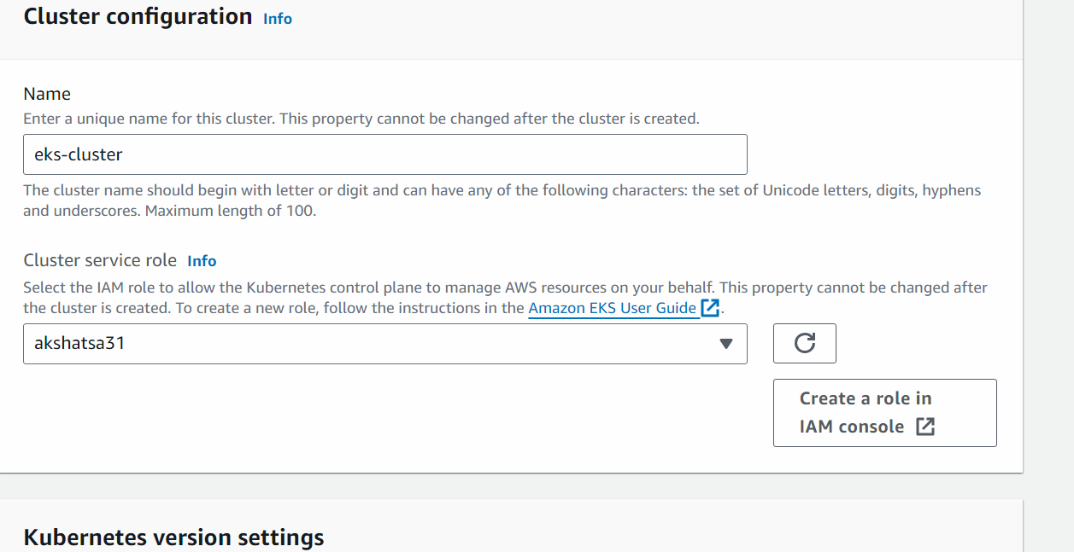

(Create a role in iam console -> next -> next)

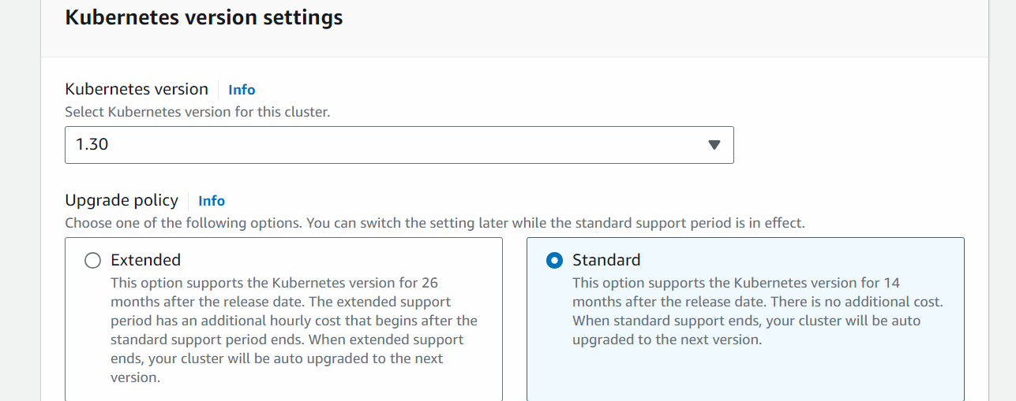

Next

######################

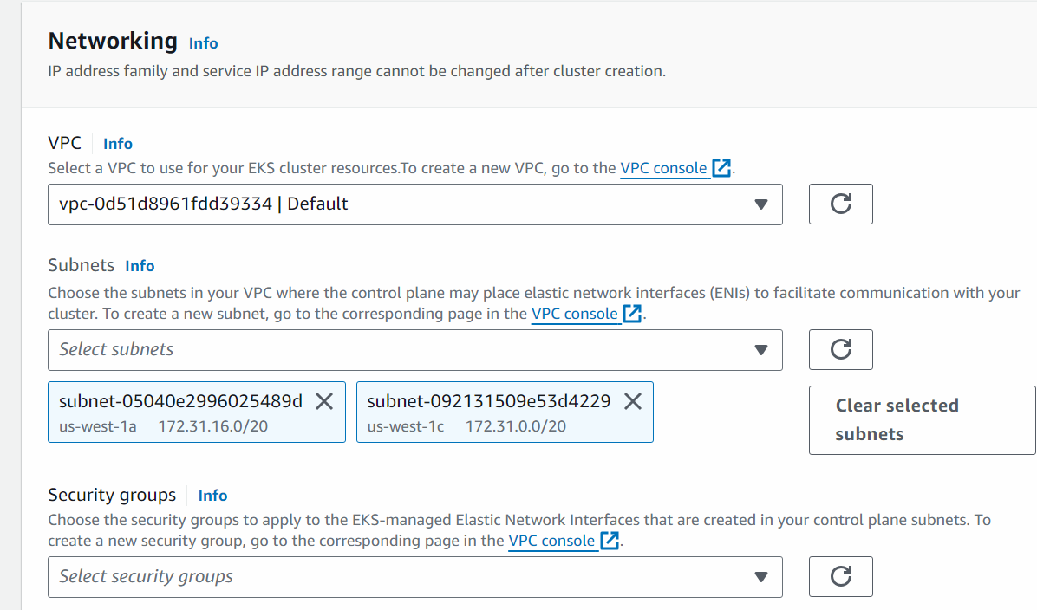

## DO NOT SELECT DEFAULT SECURITY GROUP

Go to ec2 -> go to security group -> create a security group will all traffic enabled

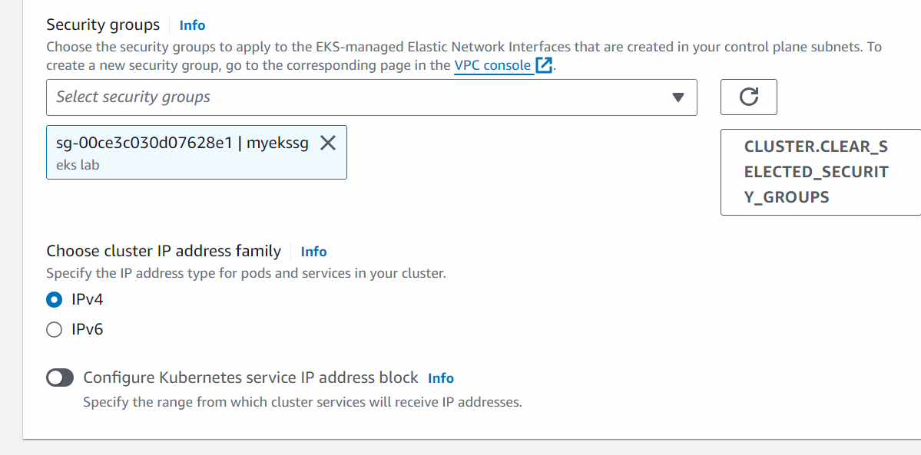

Next

Next

Next

Next

Create

After the EKS cluster is created then we will create the node group

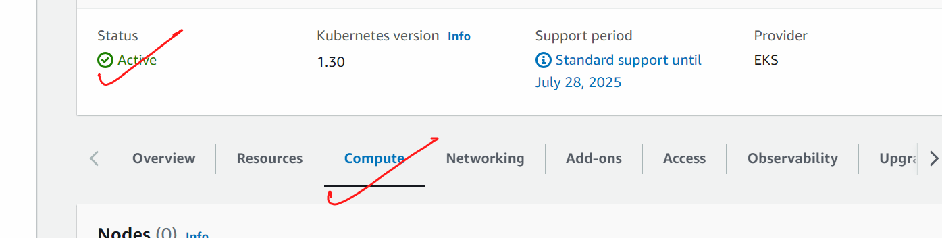

Add node group

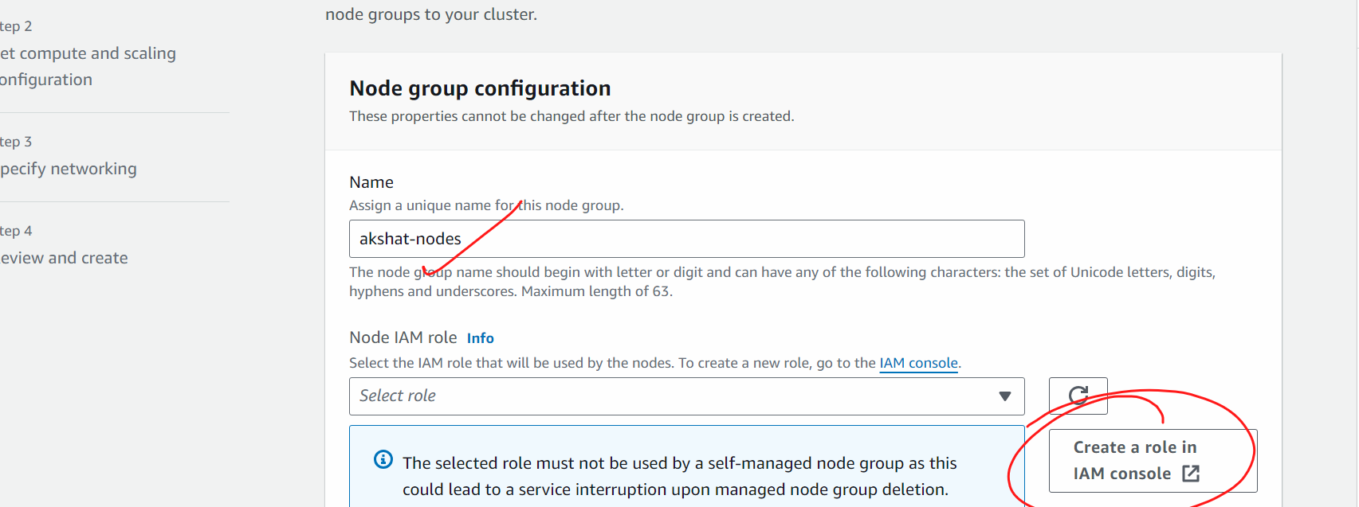

(in iam roles -< next -< next (permission will automatically set by aws) -> give some name -> create)

Next

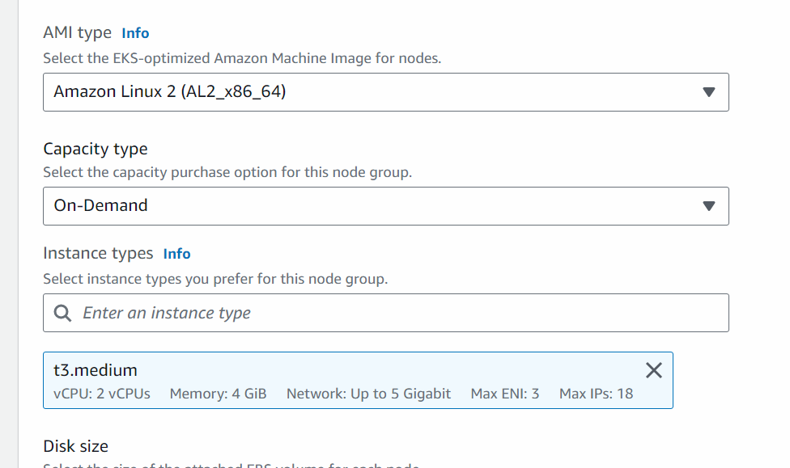

Next

Next

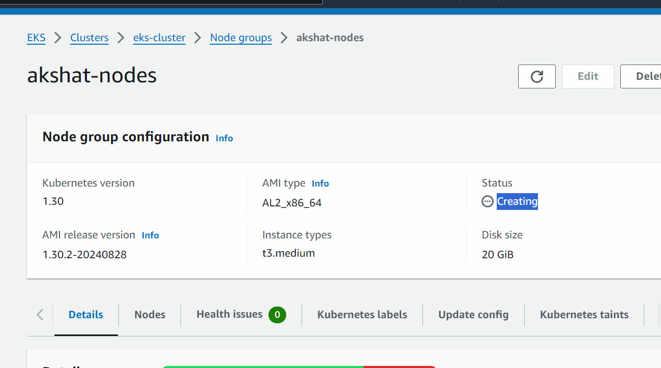

After the nodes are created we will connect the cluster from the ec2 machine so that we can talk to the cluster

Wait till the time node group is live

My eks service is now working…we need to access the eks from ec2 machine

Launch a ubuntu ec2 machine with all traffic enabled

Connect to the ec2 machine

#sudo su

# apt update

#we will now install aws cli

curl "https://awscli.amazonaws.com/awscli-exe-linux-x86_64.zip" -o "awscliv2.zip"

apt install unzip -y

unzip awscliv2.zip

sudo ./aws/install

We will generate access key and secret access keys

In the machine ,  
  
# aws configure

Put access key and secret access keys there

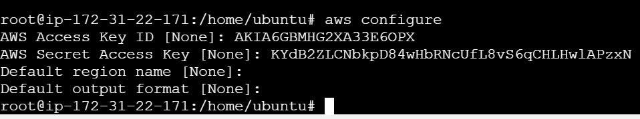

After this is done,,,,,

We will connect this machine with eks cluster

aws eks --region example_region update-kubeconfig --name cluster_name

(check the recording from 10:37 pm -10:39 pm)



sudo apt update

curl -LO "https://dl.k8s.io/release/$(curl -L -s https://dl.k8s.io/release/stable.txt)/bin/linux/amd64/kubectl"

chmod +x ./kubectl

sudo mv ./kubectl /usr/local/bin/kubectl

kubectl version --client

sudo curl --silent --location "https://github.com/weaveworks/eksctl/releases/latest/download/eksctl_$(uname -s)_amd64.tar.gz" | sudo tar xz -C /usr/local/bin

eksctl version





# vi pod1.yml

